WiRE-FRAME

FLIGHT FARE PREDICTION

Table of Contents

1.HOME PAGE 3

1.1 What is “Enter absolute path.”? 3

1.2 What is Input File Predict? 3

1.3 What is Results Section? 4

# 1.HOME PAGE

We have created home page section in such a way that user will feel very easy to interact with our product. Here is how our home page is 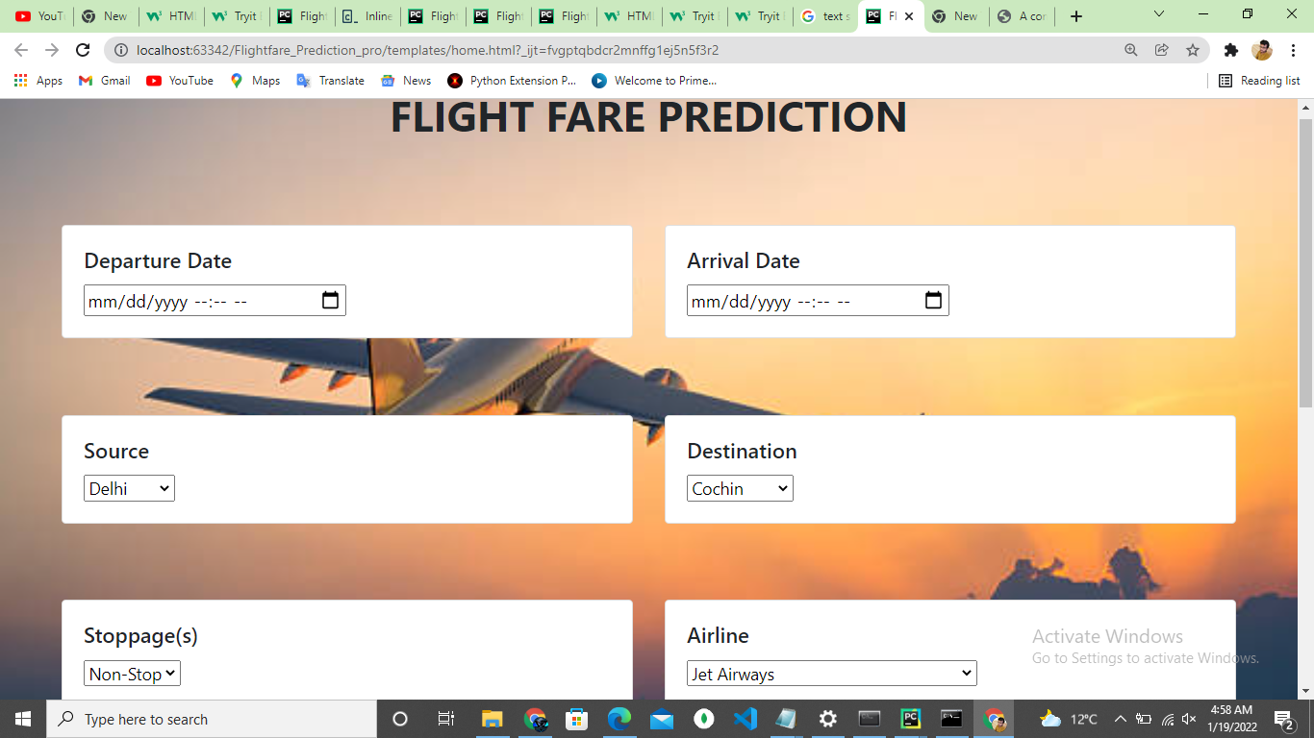

## What is “Enter absolute path.”?

Ans) In this place You have to paste the location of the folder in which the files are present.

For example folder name is Raw_Data and it is placed in D drive and then the path will be

D:\Raw_Data.

## What is Input File Predict?

Ans) Suppose you have pasted the path inside the section ‘Enter absolute path’. Now when you will hit button Input File Predict . The path file will go from html page to our main.py file and after that .csv files present inside it will be validated and prediction will be done.

## 1.3 What is Results Section?

Ans) When user fill all the detail then they will get the result on this page in the below